AMANA TRUST DIAGNOSTICS
AND CLINICAL SERVICES LIMITED
No 15, C Tudun Wada Bus Stop, Nasarawa LGA, Kano State.
Phone: +2348164093504, +2348033390574
Email: amanatrust2022@gmail.com

4/13/2026 11:09:37 AM

NAME: AISHA ISHAQ | Age:Ad | Sex:F | Ref No:00010
Clinical Details: USG Pelvic |  |  |  | US:10

REAL TIME PELVIC ULTRASONOGRAPHY EXAM: REVEALED:

URINARY BLADDER: Distended with urine with normal mucosal thickness. No gross masses or stone seen.

UTERUS: Anteverted and empty measuring 59mm in AP diametre. No evidence of pregnancy no retained product of conception. No focal lesion demonstrated. Myometrial and central endometrial echoes are preserved minimal fluid is noted within the endometrium likely blood. Right and Left adnexia are free.

CUL-DE-SAC: No sonographic abnormalities detected in anterior and posterior cul-de-sac.

IMPRESSION:The USS Features are suggestive of Complete Abortion.

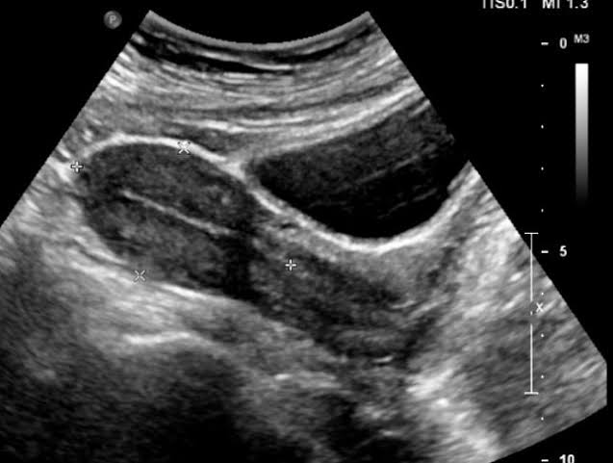
Ultrasound specialist.

